**Intellihack 5.0**

Task – 1

Weather Forecasting Challenge – Part I

Team : Outlier Rejects   
**Author :** H. D. Rivindu Ashinsa Handuwala  
**Date :** 10-03-2025

# Introduction

This report presents a **real-time machine learning system** for predicting rainfall using IoT sensors. The system ensures **data reliability**, handles **sensor malfunctions**, and delivers **daily rain probabilities for the next 21 days**.

# System Architecture and Data flow

### **🔹 System Components:**

1. **Data Sources:** IoT weather sensors & external APIs.
2. **Data Pipeline:** Real-time data ingestion, validation, and cleaning.
3. **Feature Engineering & Storage:** Stores data in **AWS S3 / PostgreSQL**.
4. **ML Model:** Uses **Random Forest** for predictions.
5. **Model Monitoring:** Tracks performance & retrains if drift detected.
6. **API & Dashboard:** Displays rain probability predictions.

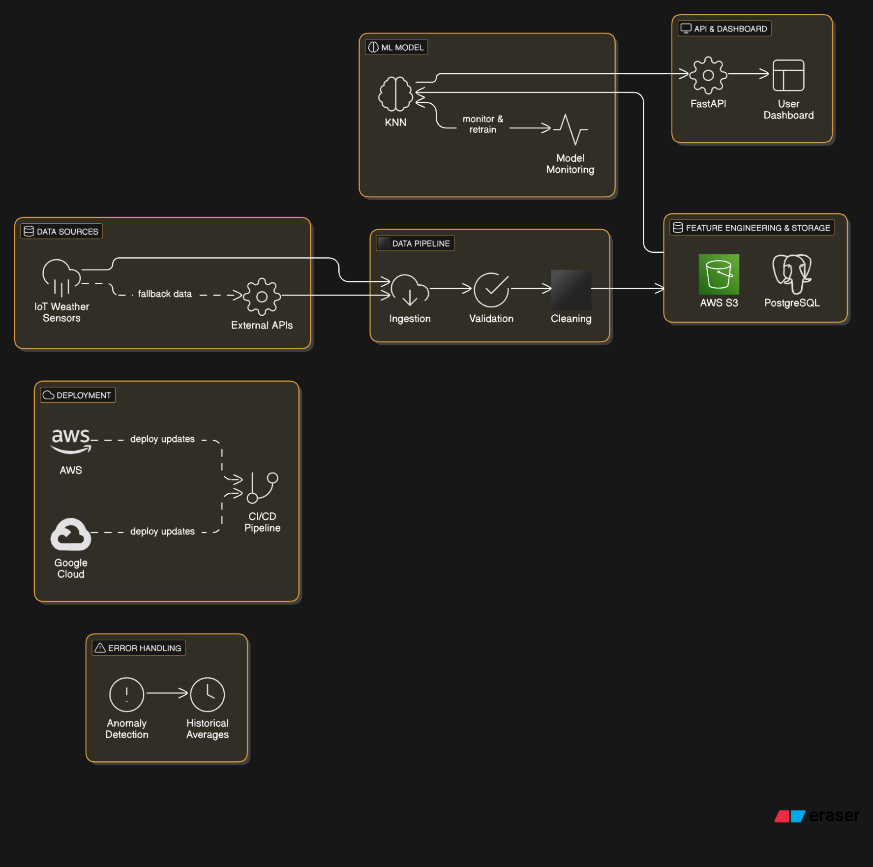

# **Error Handling & Fault Tolerance**

* **Handling Sensor Malfunctions:**
  + If IoT sensors fail, data is retrieved from external APIs.
  + Anomaly detection flags outliers & replaces them with historical averages.
* **Ensuring Reliable Predictions:**
  + **Automated retraining** every 30 days.
  + **Backup data storage** for continuous availability.

# **Conclusion & Deployment Strategy**

* **Deployment:**
  + Model hosted on **AWS / Google Cloud** with **FastAPI for inference**.
  + **Continuous Integration (CI/CD) pipeline** for model updates.
* **Future Improvements:**
  + **Edge AI** for IoT sensors to process data locally.